* **to** the west of the pool
* **to** the east
* **next to** the pool
* **behind** the pool..
* **to the rear of** the pool (к задней части)
* **one change that stands out**
* **Another noticeable change**
* **To be a feature**
* **either side of** the sports centre
* **to be upgraded**
* **toward** the east wing
* **in** the west wing
* **adjacent to** the pool
* **across from** the sports hall
* **in** the reception area
* **beside** the sports hall
* he reception area will be redeveloped
* There are plans to build dance studios
* A large indoor leisure pool is set to be built
* The outdoor courts are earmarked for removal
* The outdoor courts will be removed
* The gym is going to be expanded
* The gym is expected to be expanded
* There are proposals for a new sports hall
* A new sports hall is planned
* There are plans for new facilities such as…..

**Useful Vocabulary**

| **Nouns** | **Verbs** | **Phrases** |
| --- | --- | --- |
| Upward movement a rise an increase a surge a growth a peak  Quick changes a ﬂuctuation a variation  No Changes a period of stability a plateau  Downward Movement a fall a decrease a decline a dip a drop | Upward movement to rise to increase to surge to grow to peak to skyrocket  Quick Changes to ﬂuctuate to vary  Downward Movements to fall to decrease to decline to dip to dive to plunge | showed an upward trend showed a downward trend hit the highest point hit the lowest point reached a peak showed some ﬂuctuation ﬂuctuated wildly remained stable remained static remained unchanged stayed constant reached a plateau levelled off ﬂattened out the highest the lowest the second highest the third highest compared to  compared with relative to |

| **Adverbs** | **Adjectives** |
| --- | --- |
| sharply suddenly rapidly abruptly dramatically signiﬁcantly steadily considerably markedly slightly gently gradually steeply | sharp sudden rapid abrupt dramatic signiﬁcant steady considerable marked slight gentle gradual steep |

**Useful Grammar**  
*Sample Sentences*  
1. There was **a substantial increase** in the value of stocks on March 15th.  
2. House prices **rose dramatically** in July.  
3. The number of tourists visiting New York **fell sharply** in October.  
4. The number of students studying Economics **rose gradually** from 2001 to 2010.  
5. There was **a sharp increase** in employee turnover after the strike.  
6. Interest in environmental issues has **risen steadily** over the last 10 years.

**Prepositions:**

Prepositions are needed to describe dates, numbers or comparisons:

**Dates**  
**In** December,  
**In** 2005,  
**From** 2001 **to** 2010,  
**By** 1998,  
**Between** 1965 **and** 1969  
**Over** a ten year period

**Numbers**  
An Increase **of** 25%.  
Decreased **by** 10%.  
Fell **from** 200 **in** July **to** 150 **in** August.  
Dropped **from** 200 units **to** 120 units **in** a period of 6 months.  
Rose sharply **over** a period **of** 5 years.  
Started **at** one third and peaked **at** three thirds  
Fell **from** 30% **to** just **over** 20%

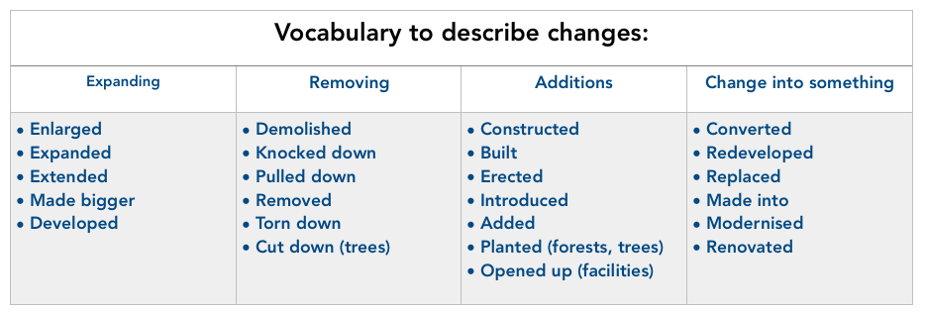

### Example sentences:

Note that the grammar used to describe changes is in the passive.

* The offices **were demolished** and the surrounding area **was redeveloped** with a new leisure centre **opening up**.
* The shopping centre **was** **extended** and the parking area **was** **enlarged** to accommodate more cars
* The trees **were** **cut down** and a new office block **was erected**.
* A railway **was** **constructed** with the **introduction** of a new train station.
* The industrial area **was** **modernised** and **made bigger** with lots of new factories being **built**
* The local government had the sports facilities **renovated** and the small park **was made into** a children’s playground
* The park **was replaced** with a new housing complex.

## Vocabulary for showing location

When describing the location of something on a map you should use phrases like:

* to the north of
* to the east of
* in the west
* to the south of
* north west of

**Prepositions** are essential when describing location on a map, such as:

* *on*
* *next to*
* *near*
* *from north to south*
* *from east to west*
* *by*
* *across from*
* *nearby*
* *between*
* *beside*
* *over*
* along